**CHAPTER 1**

**INTRODUCTION**

The labor rates are increasing steadily year on year thus making it difficult to find employees. The food industry is highly labor intensive and the biggest expense in the food industry is the cost of employing the right kind of people to do the work. One of the ways to reduce this expense is to use modern technology to replace some of the jobs done by human beings and make machines do the work.

Here we propose an “SKI Foods” that has been designed for Fast Food restaurant, Take-Out or College Cafeterias. The system can also be used in any food delivery industry. This simplifies the process of food ordering for both the customer and the restaurant, as the entire process of taking orders is automated. The online food ordering system sets up a food menu online and customers can easily place the order as per they like. Also with a food menu, online customers can easily track the orders.

The management maintains customers database, and improve food delivery service. The Restaurant management systems motivates us to develop the system.

**1.1 OVERVIEW OF THE PROJECT**

There are various facilities provided so that the users of the system will get service effectively. Increasing use of smart phones is also considered as a motivation, so that any users of this system get all service on single click. Another motivation can be considered as the system will be designed to avoid users doing fatal errors, users can change their own proﬁle, users can track their food items through GPS, users can provide feedback and recommendations and can give ratings, it will give appropriate feedbacks to Restaurant.

The major attributes that will give input to the dataset are: name, address, email-Id, mobile no, other personal related values, etc. The output will include user/customer’s Order, Bill, Feedback and Payment options. The reason why to choose this project is the idea behind project that is to solve problem of people which they are facing when they shift to different city.

The system is not only for user but also for provider who provides food service. This system is for making efficient communication between consumer and producer of the food system which will then leads to the ideal and effective system.

**1.2 Literature Survey**

Various case studies have highlighted the problems faced while setting up a restaurant . Some of the problems found during the survey in the existing system are listed below:

To place the orders customer visits the restaurant, checks the menu items available in the restaurant, and chooses the items required, then places the order and then do the payment. This method demands manual work and time on the part of the customer.

When the customer wants to order over the phone, customer is unable to see the physical copy of the menu available in the restaurant, this also lacks the verification that the order was placed for the appropriate menu items.

Every restaurant needs someone or the other to take

* 1. Overview of project
  2. Literature Survey

Chapter 1 deals with Introduction.

**CHAPTER 2**

**PROBLEM STATEMENT**

The online food ordering system sets up a food menu online and customers can easily place the order as per they like. Also, the online customers can easily track their orders. The International Journal of Computer Applications (0975 – 8887) Volume 180 – No.6, December 2017 23 management maintains customer’s database, and improve food delivery service. This system also provides a feedback system in which user can rate the food items.

Also, the proposed system can recommend hotels, food, based on the ratings given by the user, the hotel staff will be informed for the improvements along with the quality. The payment can be made online or cash or pay-on-delivery system. For more secured ordering separate accounts are maintained for each user by providing them an ID and a password.

The simulation first starts with the customer entering his/her credentials (name, ID and password). Once that has been verified, the customer can place an order specifying the quantity of the food required. Now we get a window that displays the order number, customer ID, food name, price and quantity. Once the customer finalizes his/her order, they are redirected to the payment window where the total price is displayed and the customer can select the payment method of their choice and then the customer gets a message of confirmation of order.

Chapter 2 deals with Problem statement.

**CHAPTER 3**

**PROPOSED SYSTEM**

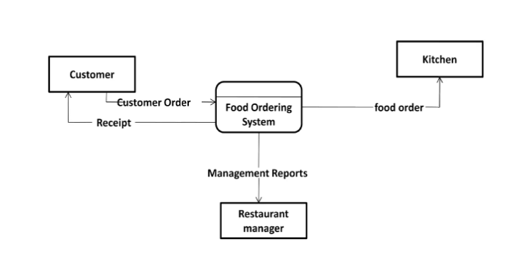To overcome the limitations of above system, an Online Food Ordering System based on Internet of Things is proposed. It is a wireless food ordering system using android devices. Android devices have gained immense popularity and have revolutionized the use of mobile technology in the automation of routine task in wireless environment. Android is a Linux based operating system for mobile devices such as smartphones and tablets. To develop a reliable, convenient and accurate Food Ordering System is considered as a general Objective of the study.

**Flow 1**

To improve the communication between the client and customers is one of the objective. The figure.1 represents the simple system architecture of the proposed system for hygienic and quality food, so he/she will search and select restaurant or home-based food service based on his category and as well as service that is veg or non-veg. Here the main function is, in what pattern user will search the service so for that purpose a part of Geo-Hashing Algorithm is used, and GPS system should be on.

To develop a system that will surely satisfied the customer service will be considered as an objective. One of the Objective is to design a system that is able to accommodate huge amount of orders at a time and automatically compute the bill. To evaluate its performance and acceptability in terms of security, user-friendliness, accuracy and reliability is an important objective.

Person can have the facility to search service by location that is home location of the person is detected with GPS and according to selected option location of nearby service get searched. Another way for searching is by cost. Here user must give input in terms of rupees that in what range he/she need service per plate if there are any service provider within that area than the list will display.

User can also search by rating. The service that has rating is checked by user given rating and if matched it will give the list of service. Search can be done by accepting distance from user in which user need to search and displaying service provider within that distance. User can communicate to service provider with the help of message box and get notification from provider end if any. On the other end provider has facility to add or reject request from person who want to join the service.

**3.1 SYSTEM DESIGN**

Food ordering app is an application which help restaurants may be large or small to optimise and have complete control over their business and customers. Nowadays these applications are grabbing the market like anything. This application helps the restaurants to do all functionalities more accurately and faster way. It reduces the manual works and improves the efficiency of restaurants. This application is helping food orderings to maintain the stock and cash flows. The software helps food orders to maintain day to day records in the system. It’s very useful in keeping a proper record of the database.



Fig 1:model1

Online food ordering is a process of food delivery or takeout from a local restaurant or food cooperative through a web page or app. Much like ordering consumer goods online, many of these allow customers to keep accounts with them in order to make frequent ordering convenient.

[**Food ordering app provides**](https://www.ordering.co/) a wide range of advantages like whether on a break, stuck in traffic or riding the bus, virtually anyone can place an order quickly and painlessly. In fact, this is better and highly desirable alternative to waiting until getting home and placing the order over the phone. It’s just one click away. Its fast, easy and comfortable to access. All is just at your fingertip. This online food ordering app is having a vast visual appeal and a strong stimulating effect on all the hungry customers. With online food ordering app, all preferences are specified directly by the customer, so there is no room for confusions or misunderstandings. It’s a service which is open to its customer [**24*7**](http://sales@ordering.co/).

By using an online food ordering system, you can give your clients the flexibility to place the orders whenever it’s most convenient for them. Even if that happens outside the business hours. Online food ordering app is much easier and considerably cheaper to create and maintain a great looking menu that will impel your customers to order from you every time they see it. No longer an issue for the customers. Switching the focus from offline ordering to online ordering means less hassle of handling undecided calling clients and the staff time lost in the process and that means significant money savings for the customers.

Whenever a [**ordering system software**](https://www.ordering.co/ordering-segments/online-ordering-system-for-franchises/) is introduced it has both advantages and disadvantages towards the business and also towards its customers. The Biggest problem ever facing by food ordering app is the place or exact location of the customer. It’s really difficult to deliver food in the remote area because of an absence of restaurants in, particularly remote areas. It’s also facing Low Food Delivery Budget Because of its feasible for long distances. There is a limited number of menu choices. Due to the time constraint mostly frozen meal can be cooked in over flame and deliver quickly to the customers. The food quality may not be good as it appears to be in some of the food ordering apps.

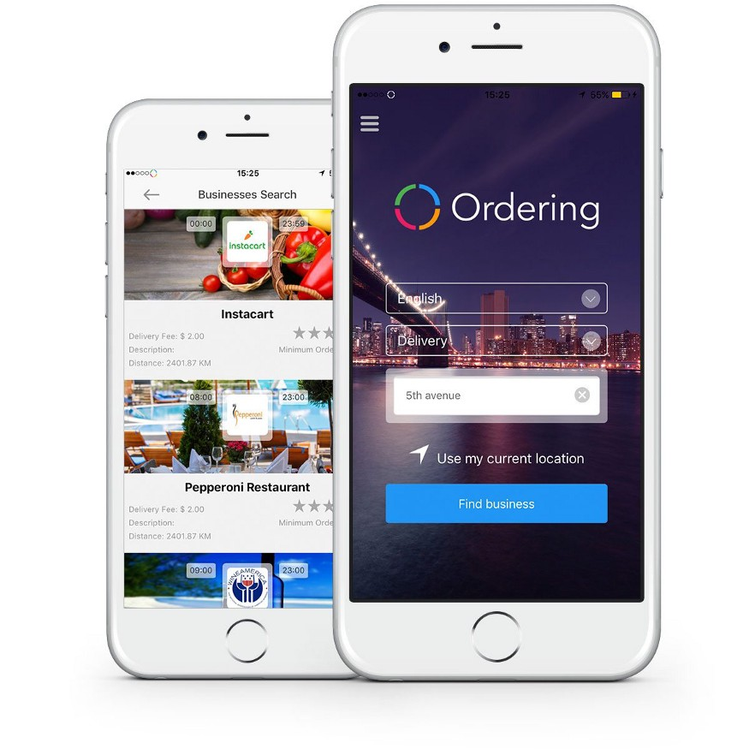 Fig 2:model2

The on-demand business model is a new one in this market. Nevertheless, it spreads globally appearing in big and small devices here and there. Food delivery, taxi services, corporate events you can apply it in a huge variety of business spheres. So, we’re not surprised many entrepreneurs pick on-demand apps as an idea for their business spheres.

To win the attention of the customers, more and more brands offer the same day delivery option. It’s not a luxury service nowadays but a necessity that many people prefer to use on the regular basis. Businesses go further and get to the customer’s house and the faster they get there the better. This is how the evolutionary way to the on-demand economy looks like. Smooth payment process and fast delivery — these are the factors of your success provided by the professional team of developers.

3.1 System Design

Chapter 3 deals with Proposed system and System design.

**CHAPTER 4**

**4.1 IMPLEMENTATION**

With the help of this system, people can easily order the food. It can also ensure that the people do not waste their precious time and use their time productively in the other works. In long run, this will ensure that it helps to reduce labor cost. This system proves to be more cost effective and reliable over other systems.

This system is difficult to forge or cheat when compared to other systems in terms of payment for the food. It is very easy to use and has least maintenance. It does not require any human intervention and thus can be called fully automated. There isn’t any limitations as such for this system, however one needs to take care of the smaller parameters like server breakdown while this system is implemented.

This system aims intuitive user interface that is well understood and easy to recommend to the customers even it is a child of age greater than 10. Even designs can be updated with simple knowledge in computer and there is no place for errors.

**4.2 CODE**

**LOGIN PAGE**

<!DOCTYPE HTML>

<head>

<link rel="stylesheet" href="C:\Users\RAJAKUMAR.S\Desktop\new ski\ski foods3.css">

<link rel="stylesheet" href="https://cdnjs.cloudflare.com/ajax/libs/font-awesome/4.7.0/css/font-awesome.min.css">

<title>Login Page</title>

</head>

<body>

<center>

<h1> LOGIN PAGE</h1>

<div class="item">

</br> </br></b>

<label><h1>USERNAME</h1></label>

<input type="text" required name="username"></br></br>

<div class="pass">

<a href="#">Forgot Username?</a>

</div>

<label><h1>PHONE NUMBER</h1></label>

<input type="number" required name="number">

</br>

</br>

</br>

<a href="C:\Users\RAJAKUMAR.S\Desktop\new ski\ski foods4.html"><button type="submit" name="GET OTP">GET OTP</button></a>

</br>

<div class="login"> or login with </div>

<div class="link">

<div class="facebook">

<i class="fa fa-facebook-f"><span>Facebook</span></i>

</div>

<div class="instagram">

<i class="fa fa-instagram"><span>Instagram</span></i>

</div>

</div></br>

<div class="signup">Don't have account?

<a href="#">Signup Now</a>

</div>

</center>

</div>

</body>

**INTERFACE PAGE**

<html>

<link rel="stylesheet" href="C:\Users\velmo\Documents\Web\Proj\Pcss.css">

<body>

<div class="navigation" >

<div class="position">

<a class="home" href="C:\Users\velmo\Documents\Web\Proj\Phtml.htm">HOME</a>

<a href="C:\Users\velmo\Documents\Web\Proj\about.html">ABOUT</a>

<a href="#contact">CONTACT</a>

<a class="order" href="C:\Users\velmo\Documents\Web\Proj\payment.html">PLACE ORDER</a>

<input type="text" placeholder="Search..">

</div>

</div>

<div class="beverages">

<a href="C:\Users\velmo\Documents\Web\Proj\Project beverages html.html">

<div class="relative">

<div class="absolute">

<div class="fade">

<div class="text">

<p>Just the refreshment you crave.</p>

</div></div></div> </div>

</a>

</div>

<div class="food">

<a href="C:\Users\velmo\Documents\Web\Proj\snack.html">

<div class="relative">

<div class="absolute">

<div class="fade1">

<div class="text">

<p>Lovin’ the snack life.</p>

</div></div></div> </div>

</a>

</div>

<div class="snack">

<a href="C:\Users\velmo\Documents\Web\Proj\ski-foods.html">

<div class="relative">

<div class="absolute">

<div class="fade2">

<div class="text">

<p>Foods...“It’s finger lickin’ good”</p>

</div></div></div></div>

</a>

</div>

<div class="combo">

<div class="relative1">

<div class="absolute1">

<div class="fade3">

<div class="text">

</div></div></div></div> </div> </div>

</body>

</html>

**EATABLE PAGE**

<!DOCTYPE html>

<html>

<head>

<link rel="stylesheet" href="C:\Users\velmo\Documents\Web\Proj\snack.css">

</head>

<body>

<div class="navigation" >

<div class="pos">

<a class="home" href="C:\Users\velmo\Documents\Web\Proj\Phtml.htm">Home</a>

<a href="#about">About</a>

<a href="#contact">Contact</a>

<input type="text" placeholder="Search..">

</div>

</div>

<div class="grid-container">

<div class="item1">

<h2><u>COMBO OFFER</u></h2>

<img src = "https://i0.wp.com/spainonafork.com/wp-content/uploads/2019/04/popcornHOR-11.png?fit=750%2C750&ssl=1" alt = "add this immage" width=150px hight=150px>

<img src="https://static.toiimg.com/photo/92494266.cms" height="150px" width="150px">

<img src="https://thefirstyearblog.com/wp-content/uploads/2020/10/chocolate-donuts-Square2.png" height="150px" width="150px">

<h4>̶₹̶̶2̶̶9̶̶0̶ ₹220</h4>

<h3>Popcorn + Sandwich + Donut </h3>

<input type="number" id="myNumber" name="number of items" placeholder="quantity" min="1" max="10" value="1">

<button type="submit" id="btn" value='v' onclick="myFunction(this.value)">ADD+</button>

<p id="demo"></p>

<script src="C:\Users\velmo\Documents\Web\New folder\function myFunction() {.js"></script>

</div>

<div class="item2">

<img src = "https://i0.wp.com/spainonafork.com/wp-content/uploads/2019/04/popcornHOR-11.png?fit=750%2C750&ssl=1" alt = "add this immage" width=150px hight=150px>

<h4>₹150</h4>

<h3>Popcorn</h3>

<input type="number" name="number of items" placeholder="quantity" min="1" max="10">

<button>ADD+</button>

</div>

<div class="item3">

<img src="https://static.toiimg.com/photo/92494266.cms" height="150px" width="150px">

<h4>₹120</h4>

<h3>Sandwich</h3>

<input type="number" name="number of items" placeholder="quantity" min="1" max="10">

<button>ADD+</button>

</div>

<div class="item4">

<img src="https://www.cubesnjuliennes.com/wp-content/uploads/2020/08/Best-Indian-Punjabi-Samosa-Recipe.jpg" height="150px" width="150px">

<h4>₹20</h4>

<h3>Samosa</h3>

<input type="number" name="number of items" placeholder="quantity" min="1" max="10">

<button>ADD+</button>

</div>

<div class="item5">

<img src="https://resize.indiatvnews.com/en/resize/oldbucket/730_-/lifestylelifestyle/IndiaTv94add1_momos-main-pic.jpg" height="150px" width="150px">

<h4>₹20</h4>

<h3>Momos</h3>

<input type="number" name="number of items" placeholder="quantity" min="1" max="10">

<button>ADD+</button>

</div>

<div class="item6">

<img src="https://loveincorporated.blob.core.windows.net/contentimages/gallery/dec824a4-e3cd-41e5-ab3d-2e37b2847389-hotdogtoppings.jpg" height="150px" width="150px">

<h4>₹40</h4>

<h3>Hot dog</h3>

<input type="number" name="number of items" placeholder="quantity" min="1" max="10">

<button>ADD+</button>

</div>

<div class="item7">

<img src="https://www.awesomecuisine.com/wp-content/uploads/2007/11/Pani-Puri.jpg" height="150px" width="150px">

<h4>₹35</h4>

<h3>Pani poori</h3>

<input type="number" name="number of items" placeholder="quantity" min="1" max="10">

<button>ADD+</button>

</div>

<div class="item8">

<img src="https://static.toiimg.com/photo/87034836/87034836.jpg?v=3" height="150px" width="150px">

<h4>₹100</h4>

<h3>french fries</h3>

<input type="number" name="number of items" placeholder="quantity" min="1" max="10">

<button>ADD+</button>

</div>

<div class="item9">

<img src="https://i0.wp.com/cookforeachother.in/wp-content/uploads/2020/10/chicken-roll-recipee.jpg" height="150px" width="150px">

<h4>₹90</h4>

<h3>chicken roll</h3>

<input type="number" name="number of items" placeholder="quantity" min="1" max="10">

<button>ADD+</button>

</div>

<div class="item10">1

<img src="https://thefirstyearblog.com/wp-content/uploads/2020/10/chocolate-donuts-Square2.png" height="150px" width="150px">

<h4>₹20</h4>

<h3>Donut</h3>

<input type="number" name="number of items" placeholder="quantity" min="1" max="10">

<button>ADD+</button>

</div>

<div class="item11">

<img src="https://www.yummyntasty.com/wp-content/uploads/2015/03/egg-puffs-1024x683.jpg" height="150px" width="150px">

<h4>₹30</h4>

<h3>Egg puff</h3>

<input type="number" name="number of items" placeholder="quantity" min="1" max="10">

<button>ADD+</button></div>

<div class="item12">

<img src="https://upload.wikimedia.org/wikipedia/commons/thumb/6/64/Chicken_Nuggets.jpg/640px-Chicken_Nuggets.jpg" height="150px" width="150px">

<h4>₹35</h4>

<h3>Nuggets</h3>

<input type="number" name="number of items" placeholder="quantity" min="1" max="10">

<button>ADD+</button> </div>

<div class="item13">

<img src="https://akm-img-a-in.tosshub.com/sites/dailyo/story/embed/202107/main_vanilla-cake_1_070921113212.jpg" height="150px" width="150px">

<h4>₹20</h4>

<h3>Tea cake</h3>

<input type="number" name="number of items" placeholder="quantity" min="1" max="10">

<button>ADD+</button>

</div></div>

</body>

</html>

PAYMENT PAGE

<!DOCTYPE html>

<html>

<head>

<link rel="stylesheet" href="C:\Users\velmo\Documents\Web\Proj\payment.css">

</head>

<body>

<div class="container">

<form action="">

<div class="row">

<div class="col">

<h3 class="title">Billing Address</h3>

<div class="inputBox">

<span>Full Name :</span>

<input type="text" placeholder="Kannan">

</div>

<div class="inputBox">

<span>email :</span>

<input type="email" placeholder="example@example.com">

</div>

<div class="inputBox">

<span>Address :</span>

<input type="text" placeholder="room - street - locality">

</div>

<div class="inputBox">

<span>City :</span>

<input type="text" placeholder="Chennai">

</div>

<div class="flex">

<div class="inputBox">

<span>state :</span>

<input type="text" placeholder="India">

</div>

<div class="inputBox">

<span>Pin Code :</span>

<input type="text" placeholder="123 456">

</div>

</div>

</div>

<div class="col">

<h3 class="title">Payment</h3>

<div class="inputBox">

Cards accepted :<br>

<img src="https://assets.stickpng.com/images/6220ac0f912013c51947f9c4.png" width="200px">

<div class="inputBox">

<span>Name On Card :</span>

<input type="text" placeholder="Mr Kannan">

</div>

</div>

<div class="inputBox">

<span>Credit Card Number :</span>

<input type="number" placeholder="1111-2222-3333-4444">

</div>

<div class="inputBox">

<span>Exp month :</span>

<input type="text" placeholder="March">

</div>

<div class="flex">

<div class="inputBox">

<span>Exp year :</span>

<input type="number" placeholder="2022">

</div>

<div class="inputBox">

<span>CVV :</span>

<input type="number" placeholder="222">

</div>

</div>

</div>

</div>

<input type="submit" value="proceed to pay" class="submit-btn">

</form>

</div>

</body>

</html>

**4.3 RESULT**

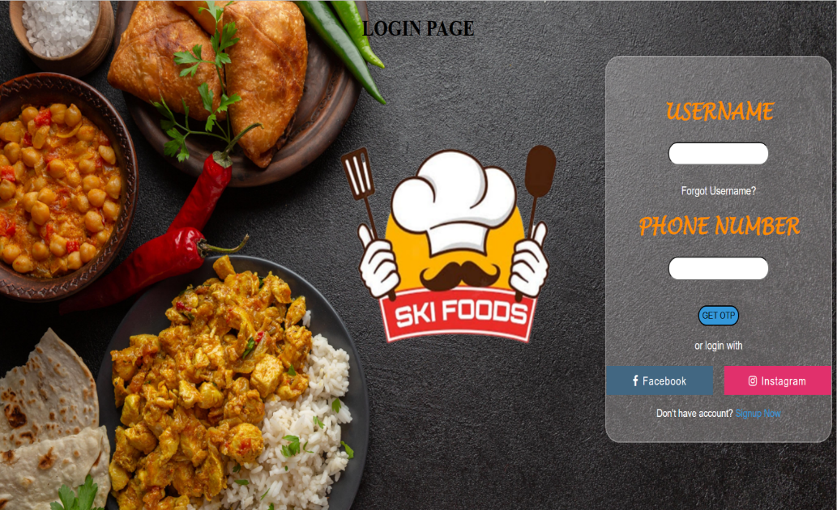

Fig 3:login pg

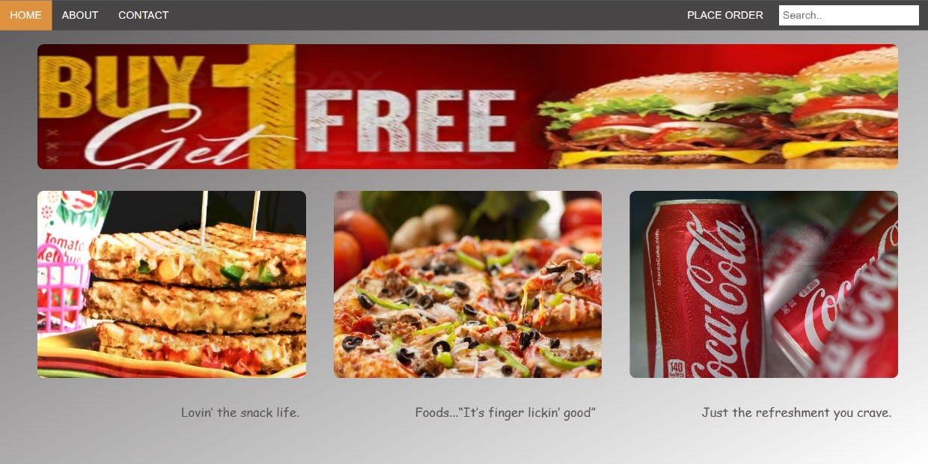

Fig 5: interface pg

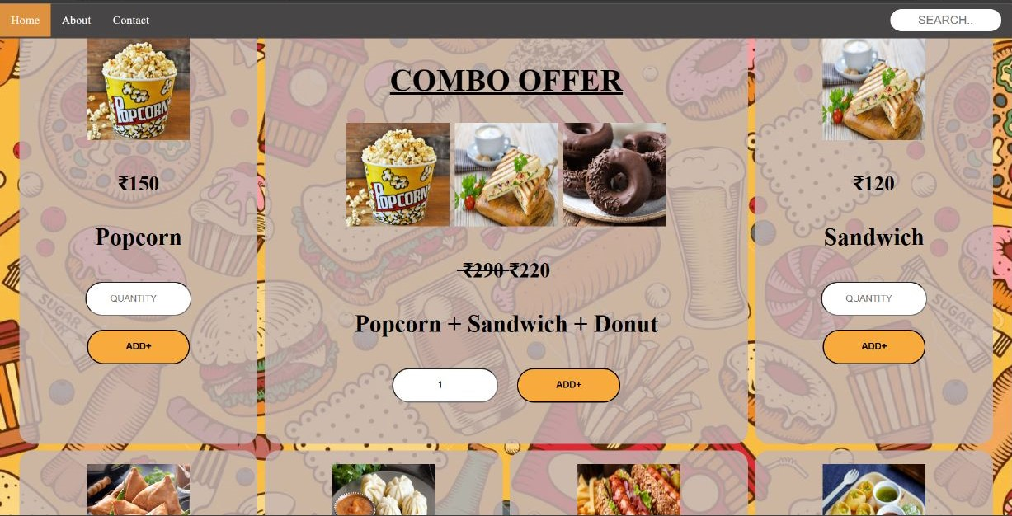

Fig 6:snacks pg

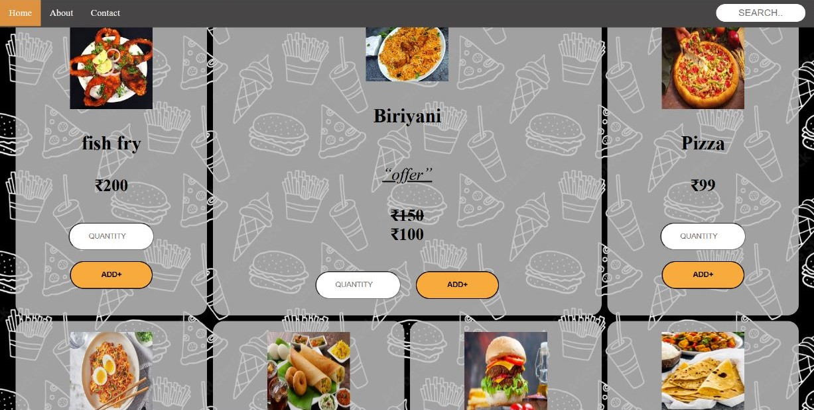

Fig 7:food pg

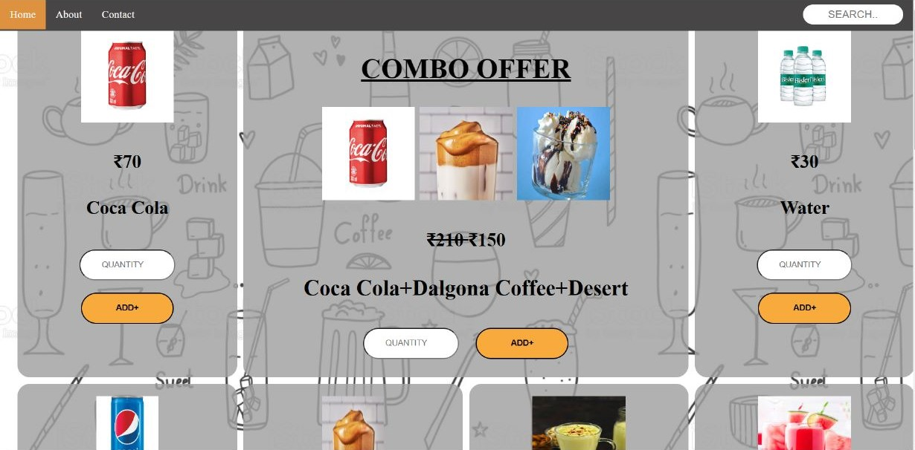

Fig 8:Beverages pg

## 

## Fig 9:payment pg

**CONCLUSION AND FUTURE SCOPE**

An online food ordering system is developed where the customers can make an order for the food and avoid the hassles of waiting for the order to be taken by the waiter. Using the application, the end users register online, read the E-menu card and select the food from the e-menu card to order food online. Once the customer selects the required food item the chef will be able to see the results on the screen and start processing the food.

This application nullifies the need of a waiter or reduces the workload of the waiter. The advantage is that in a crowded restaurant there will be chances that the waiters are overloaded with orders and they are unable to meet the requirements of the customer in a satisfactory manner. Therefore by using this application, the users can directly place the order for food to the chef online. In conclusion an online food ordering system is proposed which is useful in small family run restaurants as well as in places like college cafeteria, etc

This project can later be expanded on a larger scale. It is developed for restaurants to simplify their routine managerial and operational task and to improve the dining experience of the clients. This also helps the restaurant owners develop healthy customer relationships by providing reasonably good services. The system also enables the restaurant to know the items available in real time and make changes to their food and beverage inventory based on the orders placed and the orders completed.

**REFERENCES**

1. HTML syntaxes :- <https://www.w3schools.com/tags/default.asp>
2. CSS syntaxes :- https://www.w3schools.com/tags/default.asp
3. Images :- Google
4. Others :- https://www.tutorialspoint.com/html/index.htm